Stony Lane, Woodbury Salterton, Exeter, Devon EX5 1PP

Telephone: 01395 232649
Email: admin@woodbury-salterton.devon.sch.uk
Website: www.woodbury-salterton.devon.sch.uk

February Newsletter

'Inspiring one another to live life in all its fullness' John 10:10

Message from the Head of Learning

Welcome to the first newsletter of 2023! Firstly, I would like to share my own gratitude, and that of Mrs Finn and Mr Naish too, to all the parents, staff and children, for such a warm welcome to Woodbury Salterton CE Primary School. We are all thoroughly enjoying working with such enthusiastic and hardworking children and are incredibly excited about the upcoming adventures and learning experiences taking place this year within the school.

This term, we have also welcomed Miss Becky Shepherd as part of our office team, she too is enjoying working as part of our amazing community. Please see below for a polite reminder of the office opening times:
Mondays and Tuesdays 8.30am - 1.30pm: Miss Shepherd
Wednesdays, Thursdays and Fridays, 8.30am - 1.30pm: Mrs Clarke
On a side note, should you need to contact staff with any confidential information beyond a meeting or phone call, you can either send a letter in a sealed envelope or email admin@woodbury-salterton.devon.sch.uk, adding an attachment to your email and marking it confidential, as well as the intended recipient, in the subject line.

There have been further new faces within the school too, including that of Ms Natalie Richards, our Federation Lead for Mental Health, Wellbeing and Disadvantaged Learners. Ms Richards is an expert in her field and will be joining us weekly to support our PSHE curriculum through a focus on strategies for maintaining a healthy mind, managing anxiety and recognising emotions. Mrs Carrie Goodwin and Mrs Jenny Dell, our SENDCo team across both Littleham Church of England Primary School and Woodbury Salterton Church of England Primary School, have also begun work supporting staff and children, through leading workshops to support the development of learning behaviours and social strategies as we prepare our children to be lifelong learners and successful citizens in an ever changing world.

What a wonderful start to the year we've had with regards to the diverse learning experiences that the children have enjoyed to date. I was lucky enough to be present in class for our ‘Fire Safety and Prevention Visit’ from Devon and Somerset Fire and Rescue Service this week. I was most impressed by the mature, sensible response of the children in Classes 1 and 3, who took part in the presentations and workshops. The children in Class 1 were particularly interested in learning more about the different roles of those in the fire service, especially when there is no fire involved! Those children that I have spoken to from Class 3 have also intimated that it was a very interesting and informative experience, packed full of helpful tips and advice for staying safe. They too were fascinated by the wide range of incidents that the fire and rescue service attend - especially animal rescue! The presentation gave the children lots to think about and they were keen to discuss how to check their own homes for any potential hazards, as well as how to prepare an escape plan. Please do talk to your children about their plan – so that your whole household are prepared.

Children across the school enjoyed our first ‘Ready, Steady, Write’ day of the year and I couldn’t be prouder of the outstanding writing that came out of this occasion. This month, activities were based upon ‘The British Poem’ by Benjamin Zephaniah. As all children across the school listened to the poem, they noticed that the author begins by presenting a timeline of immigration into the UK through writing a ‘recipe’ to account for what
has made Britain the place that we know today. They recognised the key message in the poem that all members of society must be treated equally, all demonstrating unity, understanding, and respect for the future and used
this as a spring board to discuss the British Values and considering what culture is and how we are impacted by the different cultures. They came to the conclusion that the poem emphasises that is not so much the culture, what we wear or eat, how we speak or dance, what or how we celebrate that makes us British, rather, it is those shared values. It is this that inspired work for the rest of the day. Pupils in Key Stage 1 used a large map of Great Britain to create a fantastic collage of things that were British, plotting traditional foods and the birthplace of famous people whom they found to be interesting or inspiring, before using these as inspiration to write their own class poem in the style of a recipe entitle ‘Our Great Britain’. During the afternoon they reviewed some of Zephaniah’s other poems from his collection ‘We are Britain’, which celebrates the individuality of children across Britain, to write a poem about themselves as part of this ‘melting pot’. Meanwhile, in KS2 the children shared issues they see in the world around them, particularly where things aren’t right or fair or equal, exploring how these link to our British values. They worked in groups to research their chosen issue further, looking at how it affects our country and the people around us, and came up with some ways to improve or overcome these problems. Finally, everyone had the chance to help write a speech, explaining what they had researched and discussed. The children had to try and persuade others to think more deeply about each problem and help to make a change. It was truly enlightening and I was impressed by how full of fascinating and insightful ideas the children in our school are.

I am delighted to report that Number Day was also a great success! It was super to see the pupils dressed up as rock stars as we celebrate all things Maths, Time Tables Rock Stars and NSPCC. I look forward to sharing photos of the day with you on the school website.

Looking ahead to the coming weeks; the children in both KS1 and KS2 are very much looking forward to their upcoming topic days. This week, there has been a ‘buzz’ about the upper end of the school as the KS2 children speculate about the workshops and drama that will take place at Broadhembury Village Hall. Lower down, there has been lots of excited chatter about the planned ‘Spacedome’ planetarium session for after half term, of which you will receive more information soon. I suspect that the awe and wonder on our younger children's faces as they are immersed in this experience will be quite something! Already, as a result of recent learning, many of our children have been inspired to be an astronaut and I imagine this number will continue to grow!

World Book Day will be upon us once again after the half term break. The theme this year will be 'A Celebration of the English Language' where we will be asking children to come in dressed up as an interesting adjective (description word). We have been focussing a lot on Oracy this year and want to use this day as an opportunity to celebrate the rich language that we have. Some ideas the children could dressed up as are: Colourful, magical, fatigued, blustery, vibrant, puzzled, energetic etc. We will be having a vocabulary parade at the end of the day so children need to have their word on a label with their costume!

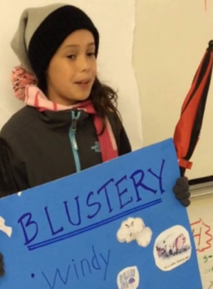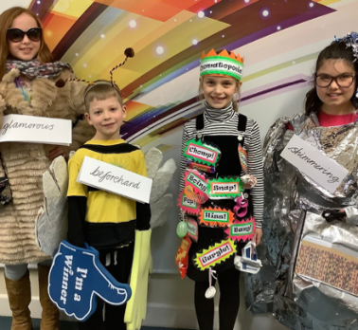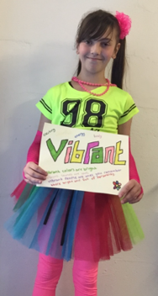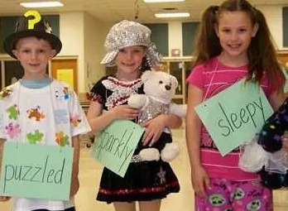

I would like to extend a huge thank you to a parent who has given up their time and effort to organise our playground sheds. We are looking forward to revamping our outdoor storage with the help of the PTFA, as well as the Early Years outdoor area, as the weather improves, and I will keep you updated on the progress that we have made in these areas.

Thank you for your support with our school uniform policy, we have noticed a significant improvement already. Please feel free to get in touch should you have any concerns regarding this. I would also like to take this opportunity to remind you that we have an ‘open door’ policy; should you have any queries or concerns regarding issues at school, I would encourage you to contact myself, or if more appropriate, your child’s class teacher, via our admin team, to further discuss these.

A final word; it seems that we have rather a problem with dog foul being brought into the school on pupils’ shoes at present. I would be grateful if you could encourage your child/ren to be vigilant to this problem when arriving at the school gates so that we may avoid future incidents.

Best wishes,
Jemma Harvey-Jones
Head of Learning

Class One Update

During the Christmas break, Mrs Finn and Miss Harvey-Jones worked hard to create an exciting and stimulating classroom environment linked to the new topic, ‘Moon Zoom’, and were delighted to welcome the parents and carers of pupils in our EYFS/KS1 setting in to share the area with their children upon their return to school. Within the setting, there is a large “loose parts” area which provides opportunities for the children to be curious, creative and constructive. The new den is a popular area for calm reading and the space tent with astronaut suits, jet packs and various props has provoked wonderful opportunities for creative role play and great turn-taking skills. The junk modelling/art station is another busy area amongst all the children and the nursery and reception children have enjoyed making rockets and creating their own planets. Moving forward, we have exciting plans in place to extend the EYFS learning area, as we repurpose our ‘resource room’ to offer further, more diverse, learning opportunities for our pupils. In recent weeks, the EYFS children have enjoyed exploring the sensory tuff trays with moon dust and space rocks. We also used them for exploring noodles as part of the Chinese New Year celebrations. Staff have been delighted by the dramatic play that we have observed.

The Science topic this term is ‘Everyday materials’ and one frosty January afternoon, following news reports of mysterious sightings in the sky, something unexpected happened in the school grounds! The children were shocked to discover a rather dramatic crash scene outside Class 1, including a broken rocket and mysterious footprints. Amongst the debris the children uncovered a variety of interesting objects such as space dust, gloop, crumpled foil, springs of coiled wire and magnetic rocks. They acted as detectives to investigate the properties of these materials and then wondered if they had been visited by Q Pootle-5! The following week children enjoyed sorting and grouping these materials and objects to create planets, such as “Planet Wood”, “Planet shiny” and “Planet waterproof”. After half term, the children will be focusing on investigations as they experiment with different types of materials suitable for an air-propelled rocket!

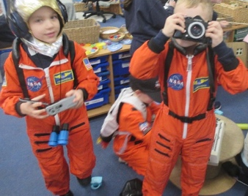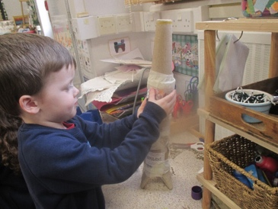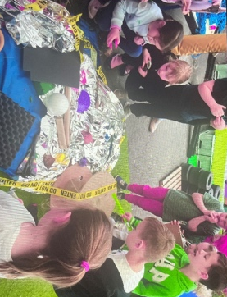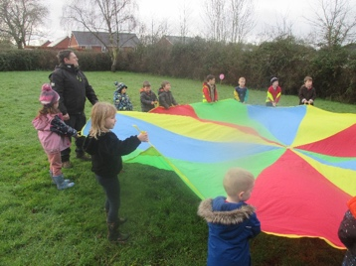

In Literacy the children have been enjoying learning, performing and creating their own riddles. Next term they will be learning how to write biographies, focussing on Tim Peake. Your child may have mentioned, that we have made some changes to our early reading provision, according to Federation policy and procedure. You should expect your Reception/KS1 child to bring home a phonically decodable book closely matched to the phonics’ knowledge that they are being taught in lessons. They will have read this three times at school to improve confidence and reading fluency and should continue to share their book at home daily. For further information, our Phonics Intent Statement can be found at: http://www.woodbury-salterton.devon.sch.uk/website/curriculum/560440 and outlines key information. Last week, all EYFS, KS1 and KS2 staff received the most up to date training in Phonics/Guided Reading and would be delighted to answer any further questions that you may have.

Looking ahead, in Art after half children will be working collaboratively to design their own planet, thinking carefully about how to experiment with colour, shape and texture using collage and colour mixing painting skills, whilst in DTEC, the class will be designing space buggies for Q-Pootle 5! Miss Finn will be inviting parents in to share a collection of the work produced during the course of the Spring Term in due course - we are sure that you will all be keen to see the work showcased on display!

As aforementioned, after half term, we are looking forward to a hosting 3 of the schools from the federation at Woodbury Salterton Village Hall for a Space Dome Experience. More details of this will follow shortly.

Key Stage Two Update

Class Two

The children in Lower Key Stage 2 have been very busy this half term learning how to write detailed descriptions of settings by writing expanded noun and adverbial phrases in Literacy lessons. They have learnt the importance of carefully selecting exciting vocabulary and have used a thesaurus to look for new and adventurous words. To challenge and extend our Year 3 and Year 4 pupils, they have been taught how to punctuate the speech of the characters in their story.

During Maths lessons, Year 4 have learnt how to find the area of shapes. They have also developed their knowledge of multiplication and division to be able to use short multiplication to solve calculations. Year 3 children have been learning the properties of both 2d and 3d shapes, before developing their calculating skills through exploring and using money.

Next half term, Year Four will be learning all about fractions and decimals in their maths lessons and Year 3 will be developing their skills of multiplication and division. Within our literacy lessons the children will be securing their use of punctuation and developing their use of compound and complex sentences.

Class Three

Our pupils in Class Three have been working hard exploring the text 'A Walk in the Desert'; a story about a parent and child exploring the Chihuahuan Desert. The children looked at how the writer managed to draw us in to the story even though there was no real action. They created pictures of the setting and looked at how to use very specific word choices to produce a detailed and vivid picture in our readers' imaginations. Mr Naish was particularly impressed by how engaged the children were when acting out their own dialogues, exploring how they could use speech to help add detail to their characters.

In Maths lessons there has been a focus on using discussion skills. Everyone has been trying hard to work on explaining their ideas clearly, as well as listening carefully to each other and asking thoughtful questions. This has helped us to work in groups on some tricky maths problems, finding a solution together. The children have been able to produce some excellent work on decimals and ratios, as well as multiplication and division as a result of this.

Looking ahead, Upper Key Stage 2 will be examining ‘Animalium’, a beautifully produced fact book about a wide variety of animals. They will be looking at how to share a range of fascinating facts with their readers, using careful organisation to create a highly professional class information book. Staff look forward to inviting parents and carers in to share the work produced by the end of this unit! We will share further details regarding this in due course.

Afternoons in KS2…

During the afternoons, all of Key Stage Two have enjoyed finding out and investigating sound within Science lessons. This has linked really nicely with work in Design and Technology, where the children have found out how musical instruments produce sound and how the pitch of sound can be changed.
Next half term, they will be using all of their new knowledge about sound to design and make their own musical instruments!
Learning in Geography lessons has been linked to the current Literacy unit; the children have been discovering what life is like in the Chihuahuan Desert. They have found out where Mexico is located in the world and how the climate affects the animals and plants that live there. After the half term break, the children will be finding out about the ancient Mayan civilisation, as well as the Mexican festival ‘Day of the Dead’. The children will design and create their own ‘Day of the Dead’ face masks, which will be displayed in an exhibition that we look forward to inviting parents and carers to share at the end of term.

Collective Worship

“I can do all things through him who strengthens me.” Philippians 4v13

This half term we have been thinking about the value of perseverance and learning about how Jesus frequently encouraged his disciples to “endure patiently” the difficulties and obstacles they encountered and to persevere in the face of adversity. He himself trusted in God even when his enemies tried to stop his work and plotted his death.

You might like to consider these thinking points with your children:

EYFS and KS1

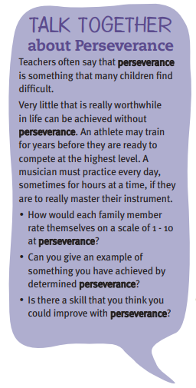
KS2

People in the past and present who have been willing to speak out against what they considered to be wrong, e.g., current situations across the world such as China.
Prophets often had to speak against the authorities of their day and they offered practical solutions to problems of injustice. What issue would you like to draw to the attention of those who have authority in your life or in local, national or interactional affairs?

We hope your family will find these ideas helpful as you explore the value and have fun together. If the children bring back something that you have done at home linked to the Collective Worship activity, or can talk about a discussion they’ve had at home linked to it, then Mrs Gray will award them with a new special sticker!

Mental Health & Wellbeing

There has been much press in recent months about children’s mental health. As part of our drive to support this we are going to include something each month in the newsletter about Health and Wellbeing. We hope you find this section useful. If you have any topics you would like us to find some helpful tips about, please let us know.

Bedtimes can be a tricky time for lots of families, The Book Trust have put together some ideas to help you with this- which will of course help the mental wellbeing of all the family. Their ‘Bath, Book, Bed’ campaign is all about helping you get your little ones to sleep - and we know how important that is for your whole family.
That's why they hosted a Twitter party where parents shared stories, tips, and advice - basically, all the hacks that work for them! They've picked out some of their favourites below to help you...

https://www.booktrust.org.uk/news-and-features/features/2018/april/11-excellent-bath-book-bed-tips-that-work---from-parents/
KS1: Can anything be true and false at the same time?
KS2: What's the best piece of advice you've ever been given? Should adults listen to children's advice more?
Question of The Month

Introducing a new challenge. Here you will find our ‘Question of The Month’. Our goal is to get the children talking about their thoughts and opinions; there aren’t usually right or wrong answers to the questions – it is simply to promote discussion. In school we are working on the children being able to talk about their learning and development, to retrieve information that they have been taught and to explain the strategies that they use to arrive at an answer. The more practice they have at this, the more it will help them. We would encourage children to discuss this question with friends and family. They may wish to write down their responses in a format of their own choosing – a short paragraph, a mindmap, a picture. We are very happy for parents, siblings, friends to also contribute to any written work that is inspired by the discussion!

Talking about Learning
Of course, you don’t need a ‘Question of The Month’ to talk to your child about their learning. When your child has had chance to process the day, and is calm and relaxed, do talk to them about their learning. What lessons have they had? What is the most interesting thing that they have learnt? What could they do this week, that they couldn’t do before?

Thank you for your help in this – we hope that they share some of the fantastic learning that is taking place within our school.
Before and After School Provision

Throughout the Spring Term, the following clubs will be available:
Monday – After School Club by Premier Sport
Tuesday – Beading/Lego Club run by Mrs Shepherd (please book via her website www.sophie-maydesigns.co.uk)
Wednesday – After School Club run by Premier Sport
Premier is also running a Breakfast Club in school (called Start Active), please see their website for more details and to book in.

Dates for your diary
- 8th February – KS2 Trip to Broadhembury for Storyteller Experience
- 13th February - 17th February – Half Term
- 24th February – KS1 Spacedome Experience
- 1st March – World Book Day (moved to 1st March to avoid the possible NEU strikes)
- 23rd March – Cake Sale at 3.30
- 31st March - Last day of term
- 17th April - Children return to school for the start of the summer term

Awards

Each week we give out two awards, LIFE Aims & Stars of the Week. Our LIFE Aims are below, and we give out awards for children who have particularly stood out in any of these aims.

Our LIFE Aim Award winners this month are:

Class 1
– Inspire each other with efforts: Guy and Henry
– Respect our environment and other people: Summer and Azariah
– Listen to each other: Jessica and Noah
– Try our best and work hard: Lily and Lottie

Class 2
–Inspire each other with efforts: Frank and Olivia
– Respect our environment and other people: Alice and Tristan
– Listen to each other: Arabella and Olivia
– Try our best and work hard: Florence and Frank

Class 3
–Inspire each other with efforts: Henry and Luca
– Respect our environment and other people: Tessa and Sienna
– Listen to each other: Skyla and Megan
– Try our best and work hard: Brodie and Joff

Star of the Week awards are given for particular achievements, effort given etc, as we like to celebrate when children have done well!

Our Stars of the Week this month are:

Class 1 – Oliver G, Cleo, James & Alfie

Classes 2/3 – Max, Olivia, Ellie, Harvey, Joff, Brodie, Kyle & Shelby

Safeguarding

Our Designated Safeguarding Lead is Miss Jemma Harvey-Jones and our Deputy Designated Safeguarding Leads are Mrs Katie Gray, Miss Nikki Weeks and Mrs Jenna Finn.

The Chair of Governors is Mrs Vanessa Briggs. The Governor responsible for safeguarding is Mr James Rees. You can contact the governors by emailing admin@broadhembury.devon.sch.uk. Emails and messages will be forwarded on for the appropriate governor to call you.

Our school’s Child Protection and Safeguarding Policy can be found online at:
http://www.woodbury-salterton.devon.sch.uk/website/policies/560292

If you have any concerns about the safety of a child you can either talk to our DSL or DDSL or you can phone Devon MASH on 01392 384964.

