Stony Lane, Woodbury Salterton, Exeter, Devon EX5 1PP

Telephone: 01395 232649
Email: admin@woodbury-salterton.devon.sch.uk
Website: www.woodbury-salterton.devon.sch.uk

March Newsletter

'Inspiring one another to live life in all its fullness' John 10:10

Message from the Head of Learning

Walking around the school in recent weeks, it has been clear to see that both pupils and staff have been extremely hard at work! From paint stained tables in the dining room and maths equipment spilled on to every surface, to timelines, factfiles and scientific jargon lovingly displayed on the walls, it is impossible to walk from one room to another without noticing the enthusiasm shared between teachers and children. It struck me how despite not being a member of the Woodbury Salterton family for much more than one half term, I feel very much ‘at home’ here and incredibly lucky indeed. The staff are dedicated and the pupils driven by a desire to learn - what more could anyone want? I would like to take this opportunity to thank all of them for making our school so special; a community that we can be proud to belong to, where we can all feel welcomed; safe and inspired.

It was no surprise that World Book Day, which encourages children to develop a love of reading every day of the year, was once again an enormous success. It was quite something to see the children gathered together for an assembly to share their costumes and discuss the adjectives that they represented. The staff would like to extend an enormous ‘thank you’ to the parents for the time, thought and effort that you have put in to supporting the children with their costumes and enabling them to be part of these experiences, both on this occasion and for Number Day. Some highlights were ‘nocturnal’, ‘discombobulated’, ‘curious’, ‘adventurous’ and ‘vintage’!

In other news, I am delighted to report that Mr Naish received news this week that our Key Stage 2 children have won the Young Writers ‘The Big Green Poetry Machine’ competition! Young Writers aims to inspire children and young adults to enjoy creative writing and reading, and with lockdown learning gaps becoming ever more apparent nationwide, this is more important that ever. Feedback from the panel included “We loved reading every single entry we received from Woodbury Salterton CE Primary School and I am delighted to let you know that the poems written by your pupils have been chosen for publication in ‘The Big Green Poetry Machine - Amazing Poets’, which is amazing!” Parents of these pupils will receive a letter including a permission form and details should you wish to purchase this publication. We are all so proud of our pupils - congratulations!

You will have seen that you have received an email regarding parents’ evening, which will be held on Wednesday 22nd March. Please remember that there will be a sign-up sheet on the school's main entrance door, where appointments can be made from Wednesday 8th March onwards. As outlined in the email, please book an appointment with the class teacher who teaches your child the core subjects as outlined below:
If your child is in Nursery, Reception or year 1, please book an appointment with Mrs Finn.
If your child is in year 2 or year 3, please book an appointment with Miss Weeks.
If your child is in year 4, year 5 or year 6, please book an appointment with Mr Naish.
Of course, if you would like to discuss your child's learning with an additional member of staff, please email the school office and we will endeavour to find an appointment time. If you have any questions regarding parents’ evening, please do not hesitate to contact the school via the school office.

The school office has recently received complaints from the wider public regarding parking on the road and kerbside directly in front of the school. This has caused disruption to the local community, but more importantly is a health and safety risk to our pupils and staff. We politely request that you find a suitable place to park your car, even when briefly dropping off or collecting your child, to ensure that no further issues arise.

Thank you all for your continued support.
God bless and have a lovely weekend.
Best wishes from Jemma Harvey-Jones and the staff at Woodbury Salterton CE Primary School

Class One Update

This week, Class 1 have been busy working in small groups, to design a special Coronation bench, as part of the ‘Tower of London Schools’ Coronation Competition’! We were invited to create an illustration for specially designed Coronation benches to mark the Coronation of King Charles III. To introduce this exciting project, the children explored how the upcoming coronation is a moment of transition and they were encouraged to think about the values and symbols which they wished to define the new era. The children were excited to hear that fifteen winning schools will work with an artist from Wild in Art to bring their designs to life, each creating an illustrated bench which will be displayed in pride of place at the Tower of London during the Coronation celebrations in May 2023. The winning benches will then be transported to the winning schools, where they will remain forever as a lasting legacy of the Coronation. Winning schools will also be offered a VIP trip for one class to visit the Tower of London in summer 2023, for which they will receive a bursary to cover travel costs. Children taking part in this visit will have the opportunity to see their bench and take part in themed activities. Every school entering the competition will be entered into a lottery to win a free class visit to the Tower of London in autumn 2023 or a set of Coronation bunting featuring some of the illustrated bench designs. The children created some beautiful designs with some intricate crowns, Union Jack designs and national flowers of the UK. These designs will be displayed on our new British Values display, which we would encourage you to view when you visit for parents’ evening. Good luck everyone and fingers crossed!

It is apparent just how artistic and creative Class 1 children are when we see the imaginative models created in the craft/junk modelling area but also in our Art lessons. This term the focus is on using Paint and Collage to create their own Planets. Most recently, Year 2 have been using paint to experiment with mixing warm and cool colours, whilst Year 1 have been making secondary colours and then experimenting with tints and shades. These colour mixing skills will then be used to represent the properties of their made up planets. Finally, they will apply different collage techniques to represent the texture and patterns of their planets. Do visit our new Art display outside the classroom, which represents the childrens’ creative learning journey.

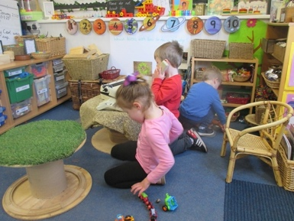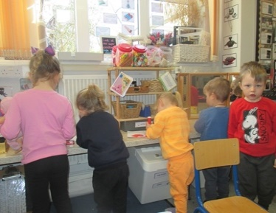

We are also focussing on History this half term and learning about how space travel has changed over time and also why Neil Armstrong, Tim Peake, Yuri Gagarin and Helen Sharman are so significant. For this week’s home learning task we are going to ask all children to complete their own timeline so far, using photos showing key milestones and changes so they an appreciate how timelines work. The Class 1 teachers have promised to share their timelines with photos from the past too, which we are sure will both fascinate and amuse the children!

Last week, the children enjoyed welcoming children from Branscombe, Farway and Broadhembury to our school to share the Space Dome experience. The children had to crawl through a tunnel to get inside the inflatable dome where they learnt about Earth and Beyond as part of a visual presentation. We expect that they are now able to inform you that the Earth, Moon and Sun are separate spherical bodies and that the Sun is a star and gives light, warmth and shines all the time. Additionally, they learnt about gravity, day, night and year, the Moon and how we see it, the importance of the Earth, highlighting air and water, the compass, the light, brightness and colours of the stars and the importance of the North Pole Star.

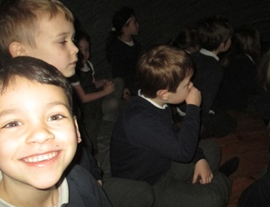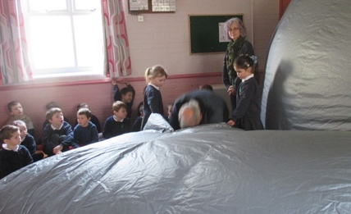

The EYFS unit has come alive this week with a focus on Spring and signs of the changing seasons; the children have thoroughly enjoyed investogating planting carrots in the sensory area and decorating daffodils. Next week our Spring theme continues as we look at the ‘Spring garden’.

A final word… We would like to say how well the children have been adapting to the new morning routines and it is having a brilliant impact on the children’s learning in Phonics, Spelling. Literacy and Maths. As you will be aware, Year 2 now join Miss Weeks with Year 3 and Year 1 remain with Reception and Nursery with their class teacher and Miss Ballard. Well done!

Key Stage Two Update

Class Two

Over the course of the last fortnight, Years 2 and 3 have read the text ‘Goodnight Spaceman’ by Michelle Robinson and have discussed a great deal of new, exciting vocabulary that they met whilst reading the book. They have been busy learning about nouns and adjectives and have written some super noun phrases to add description to their writing. As well as this, the children have been thinking carefully and identifying rhyming words that they can use in their stories. They have written some lovely rhyming couplets all about the beach in their class story. Next week the children will apply all that they have learnt to write their own rhyming story about a character’s dream. Our next unit will be based on the text, ‘Amelia Earhart’ which will form the basis of our learning in Literacy. The children will learn how to write using a more formal style and will develop their use of conjunctions in order to extend their sentences as they work towards writing a biography.

In Maths, the children have been working hard to develop their understanding of multiplication as repeated addition. They have used maths equipment, drawn pictures and written number sentences to help them solve multiplication problems. They are now learning about division and how division is the inverse calculation of multiplication. It is really important that your child can count on in steps of different sizes so the children have been practising counting in twos all the way to 100. Some children are still finding this a bit tricky so please practise this with them whenever you can! Please see below the National Curriculum expectations for counting for years 2 and 3.
- By the end of year 2 children need to be able to count in steps of 2, 3, and 5 from 0, and in tens from any number, forwards and backwards.
- By the end of Year 3, children need to be able to count from 0 in multiples of 4, 8, 50 and 100; find 10 or 100 more or less than a given number.
Our next unit in maths will be length and height and the children will learn how to accurately use a ruler and to measure in centimetres and metres. They will then solve problems involving length and the four operations.

Class Three

During morning lessons, years four, five and six have been working hard exploring ‘Animalium’, a beautifully illustrated book about an exciting range of animals. They have looked at how paragraphs are carefully structured to keep adding more information and begun to explore different ways to create our own high-quality sentences, full of facts about different animals. The children were particularly good at researching technical vocabulary that they could use to make their writing look even more professional. Everyone has been working hard and sharing some brilliant examples of writing. Over the coming weeks, we will look at how to put these wonderful sentences into well-structured to create our own animal information pages as part of a class book.

We have also had the chance to look at some fantastic stories in our Guided Reading sessions. Year four have begun looking at 'A Bear Called Paddington' by Michael Bond whilst years five and six have begun Louis Sachar's 'There's a Boy in the Girls' Bathroom'. We have been looking at finding clues from the text and our own knowledge of how stories work to draw inferences about characters and begin to make predictions about the stories. Everyone has joined in really well with these discussions and shared some fantastic ideas. We'll soon find out if we were right or not!

In Maths lessons, year six have just finished looking at algebra. They have all worked really well on what can be a daunting topic. They even began to solve two equations at once, using tables and substitution to work out the values of two unknowns - not an easy task! Years four and five have been working on fractions, developing their understanding of whole and mixed numbers and linking these to improper fractions. Year five are now ready to start looking at percentages while year four will be thinking about adding and subtracting fractions. All of the children have been doing some excellent work with some challenging learning. They have been developing their confidence in discussing problems and explaining their reasoning, an important skill that we will continue to work on over the coming weeks.

Afternoons in KS2…

To start our history work on the Maya civilization, Class 2 attended a wonderful story session which was led by the talented Clive Pig who told some great stories based on the Maya culture and traditions. It was lovely to watch the children entranced by his story telling. Back in class we have been looking at historical artefacts to gather information about the past and to find out more about the Maya way of life.

In our Geography lessons, the children have enjoyed researching and working in a group to present a PowerPoint of information about the Chihuahuan Desert in Mexico. They have looked at the location of the desert and how this affects the climate and what lives and grows there. They have also looked at how animals and plants have adapted in order to live in such harsh conditions. Alongside this work, the children have really enjoyed learning the capital cities of countries across the world. We have been impressed with how many children have gone home and written quizzes for the rest of the class to complete to help them learn the capitals!

The children have now completed their Science unit on sound and have since been applying all that they have learnt to make the musical instruments that they have designed. In the weeks leading up to the end of term the children will then work in groups to produce a small piece of music that they will perform to each other. The new area of Science that the children are now studying is electricity and the children in Year 3 and 4 have been identifying electrical objects and thinking about electrical safety, whilst the children in Years 5 and 6 have enjoyed building circuits and testing whether or not a circuit will work. Everyone is most excited that all this work on developing such skills will culminate in producing a light up card in Design and Technology by the end of the term!

In our art lessons we have researched the Mexican festival ‘Day of the Dead’ and the children will be researching art work connected with this festival before designing and making their own skull using Mod-Roc.

Forest school has continued to be a highlight of the week for many children. Some of the activities have included making a drum, making a stretcher to carry a friend and building and lighting fires. As well as learning new survival skills, it produces a wonderful opportunity each week for the children to develop skills such as co-operation, trust, initiative, team-work, resilience and problem-solving to name just a few!

Photographs from the last month…

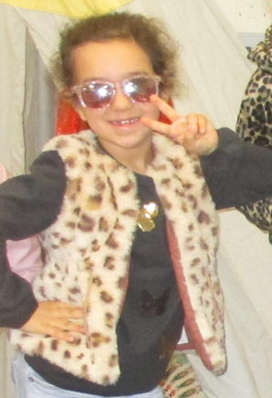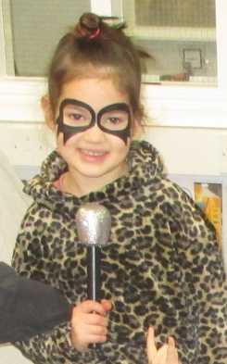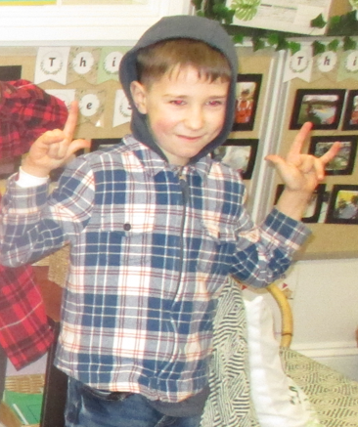

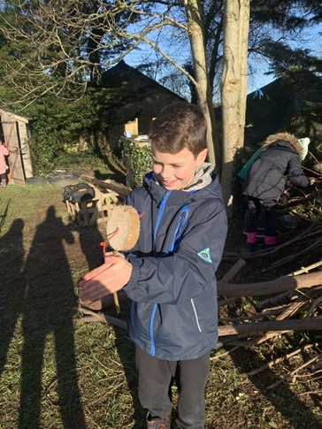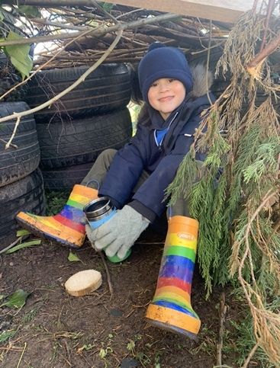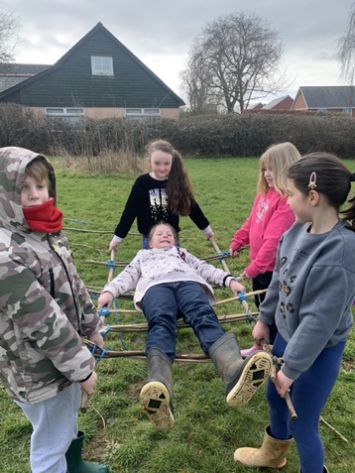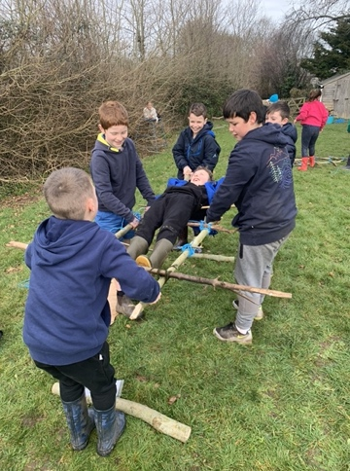

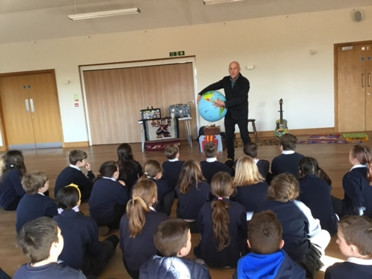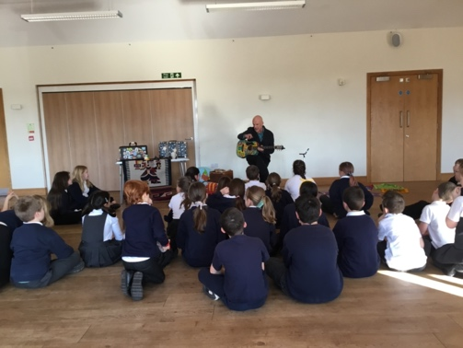

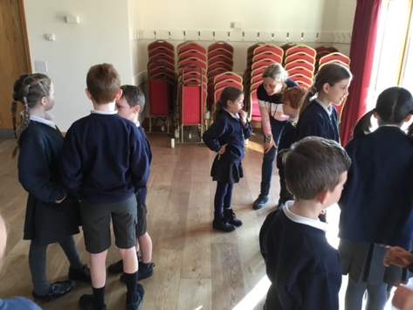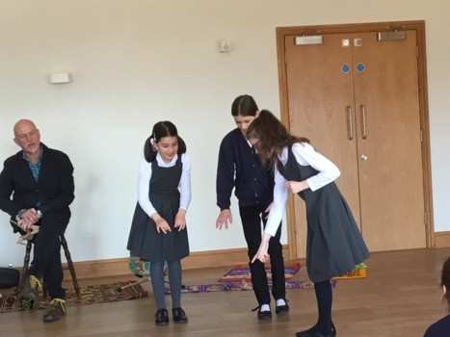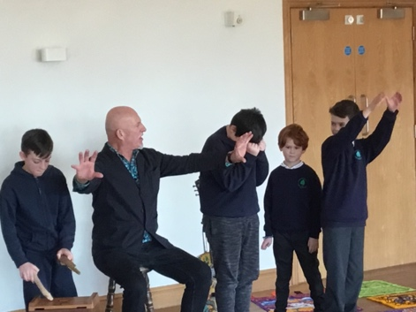

Collective Worship

This term we will be focussing in school on the value of Service. We hope your family will find these ideas helpful as you explore the value and have fun together. If the children bring back something that you have done at home linked to the Collective Worship activity, or can talk about a discussion they’ve had at home linked to it, then Mrs Gray will award them with a new special sticker.
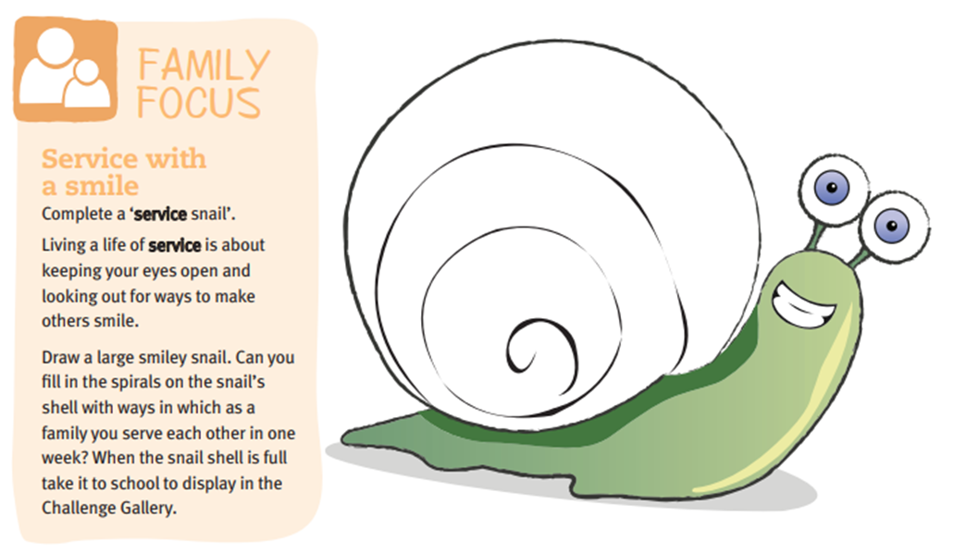

Question of the month
KS1: What can you do to help yourself to calm down when you are angry? Now, what can you do to cheer yourself up when you are sad? Finally, what can you do to help yourself when you are worried?
KS2: Can I think myself happy? Does focusing on happiness make you happy? Is it possible to “think” yourself into being happy all the time by positive thinking?

Wellbeing

There has been much press in recent months about children’s mental health. As part of our drive to support this we are going to include something each month in the newsletter about Health and Wellbeing. We hope you find this section useful. If you have any topics you would like us to find some helpful tips about, please let us know.

The BBC have produced a Mental Health Toolkit called Headroom. This has been set up to give you tools to help with troubles surrounding mental health. Whether it is everyday tips, sounds to relax your mind, strategies to cope with parenting right now or films to get you talking, the BBC are there to help you look after yourself and your loved ones. As the children return to school next week it is worth having a look at the section on sleep to help them through busy days. Follow the link below to find all of the toolkit and resources for adults and children.

https://www.bbc.co.uk/programmes/articles/YfRzhXDKSZQxFVn30TlXBj/your-mental-health-toolkit

Before and After School Provision

Throughout the Spring Term, the following clubs will be available:
Monday – After School Club by Premier Sport
Tuesday – Beading/Lego Club run by Mrs Shepherd (please book via her website www.sophie-maydesigns.co.uk)
Wednesday – After School Club run by Premier Sport
Premier also runs Breakfast Club in school (Start Active), see their website for more details and to book in.

Dates for your diary
- 9th March - Aesthetics Festival
- 15th & 16th Match - NEU Teacher Strikes (Further details will come out nearer the time)
- 22nd March - Parents’ Evening
- 23rd March – Cake Sale at 3.30
- 29th March - Easter Service at 2.30pm
- 30th March - Dance Festival
- 31st March - Last day of term
- 17th April - Children return to school

Awards

Each week we give out two awards, LIFE Aims & Stars of the Week. Our LIFE Aims are below, and we give out awards for children who have particularly stood out in any of these aims.

Our LIFE Aim Award winners this month are:

Class 1
– Friendly, kind and helpful: Eva & Oliver A
– Keep ourselves and others safe: Cleo & Herbie
– Polite and have good manners: James & Alfie

Class 2
–Friendly, kind and helpful: Charlie & Ellie
– Keep ourselves and others safe: Ivy
– Polite and have good manners: Alice & Max

Class 3
–Friendly, kind and helpful: Harvey & Kyle
– Keep ourselves and others safe: Henry & Megan
– Polite and have good manners: Sienna & Joff

Star of the Week awards are given for particular achievements, effort given etc, as we like to celebrate when children have done well!

Our Stars of the Week this month are:

Class 1 – Luke, Summer & Lily
Class 2 – Finley, Panka, Ellie
Class 3 - Olivia, Tessa & Megan

Well done to you all! For photos, please see our school website.

Safeguarding

Our Designated Safeguarding Lead is Miss Jemma Harvey-Jones and our Deputy Designated Safeguarding Leads are Mrs Katie Gray, Miss Nikki Weeks and Mrs Jenna Finn.
The Chair of Governors is Mrs Vanessa Briggs.
The Governor responsible for safeguarding is Mr James Rees.
You can contact the governors by email on clerk@littleham.devon.sch.uk Emails and messages will be forwarded on for the appropriate governor to call you.

Our school’s Child Protection and Safeguarding Policy can be found online at:
http://www.woodbury-salterton.devon.sch.uk/website/policies/560292

If you have any concerns about the safety of a child you can either talk to our DSL or DDSL or you can phone Devon MASH on 01392 384964.

